Church Attendance Tracker Program – (offline version)
User guide

Written by: Clifford Dela Cruz

Contents
What is the church attendance tracker program? 3
Why is there a need to create a Church Attendance Tracker Program? 3
Requirements to set the Church Attendance Tracker program 3
Parts of Attendance Tracker program 4
1. Recording Attendance for Existing and New Attendees 4
2. Maintaining Attendees details 6
3. Download attendance report 8
4. Delete Person to delete user and recorded attendance 10
5. Update Person to update user and recorded attendance 11

What is the church attendance tracker program?
The Church Attendance Tracker is a lightweight, user‑friendly application designed to help churches record, manage, and review attendance data efficiently. Built using Python and Tkinter, and storing data in Excel files, the program provides a simple interface that allows volunteers and ministry leaders to:
- Register attendance for each service
- Maintain a clean and organized member list
- Search, edit, and update member information
- Generate attendance reports for specific dates or date ranges
- Export data for ministry reviews, planning, and reporting

Why is there a need to create a Church Attendance Tracker Program?
The program aims to address the following issues during attendance taking:
- Missing or inconsistent records
- Difficulty identifying trends (e.g., newcomers, absentees, growth patterns)
- Time-consuming manual reporting
- Challenges in supporting pastoral care and follow-up
- Scattered, disorganized data.

Requirements to set the Church Attendance Tracker program
- Excel spreadsheet “Attendance Tracker.xlsx” – this is the required as this will serve as the “database”
- Python program “attendance_tracker_program.py” – this serves as the front-end, to take in attendance and save into the “Attendance Tracker.xlsx”
Required packages:
- Tkinter, ttk, messagebox – for GUI window, buttons, drop down list, message box
- pandas – for reading and writing to excel sheet
- tkcalendar – for GUI calendar
- datetime – to work with date and time.

Parts of Attendance Tracker program

Main Screen
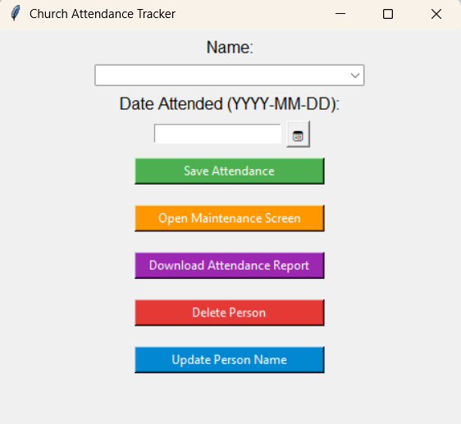

Attendance Tracker Excel sheet
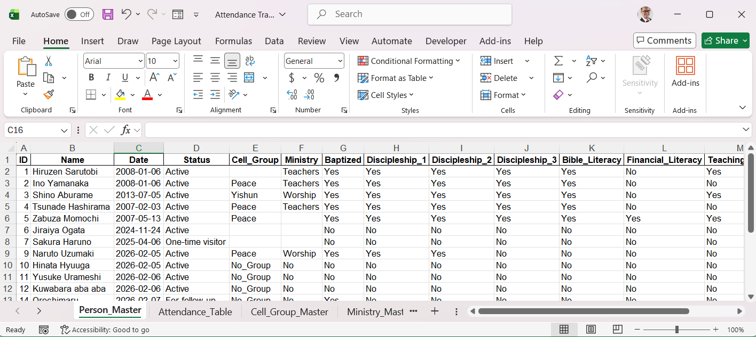

Recording Attendance for Existing and New Attendees

1a. Recording Attendance for an existing attendee
If the attendee already exists in the system, begin typing part of their name in the search field. The dropdown list will automatically filter the results.
You may either:
- Press the Down Arrow key to highlight the correct name, or
- Click the dropdown arrow to manually select the name from the list
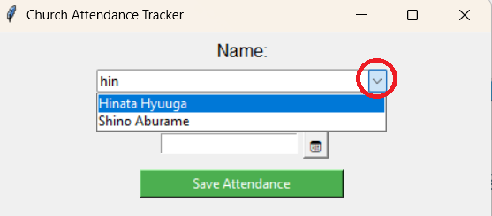

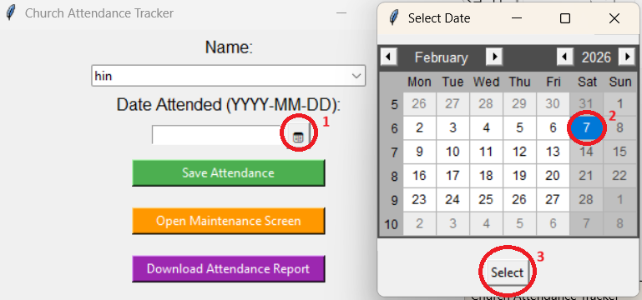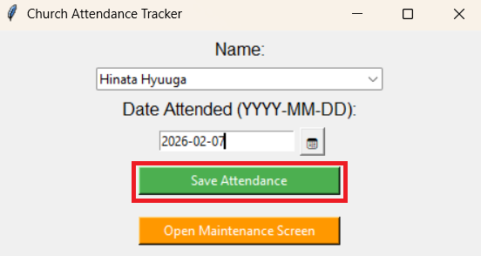

Once the correct member is selected, click Save Attendance. The system will immediately record the attendance for the selected date and service.
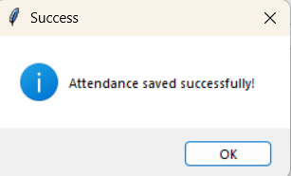

1b. Recording Attendance for a new attendee
If the attendee does not yet exist in the system, type their full name into the search field and click Save Attendance.
The program will display a confirmation prompt asking whether you would like to add this new person to the member list and proceed with recording their attendance.
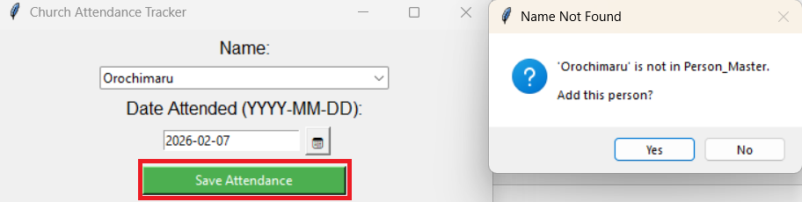
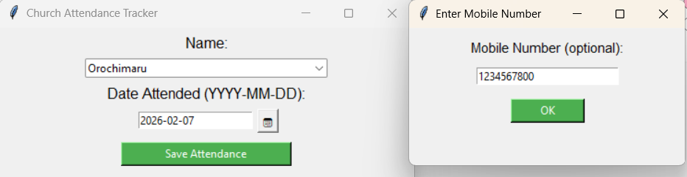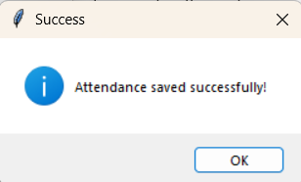
- If you confirm, the system will create a new member record and save the attendance entry.
- A pop‑up window will then appear, allowing you to enter the attendee’s mobile number. This field is optional and may be left blank if the information is not available.

Data is saved in ‘Attendance Tracker’ spreadsheet under ‘Person_Master’ worksheet
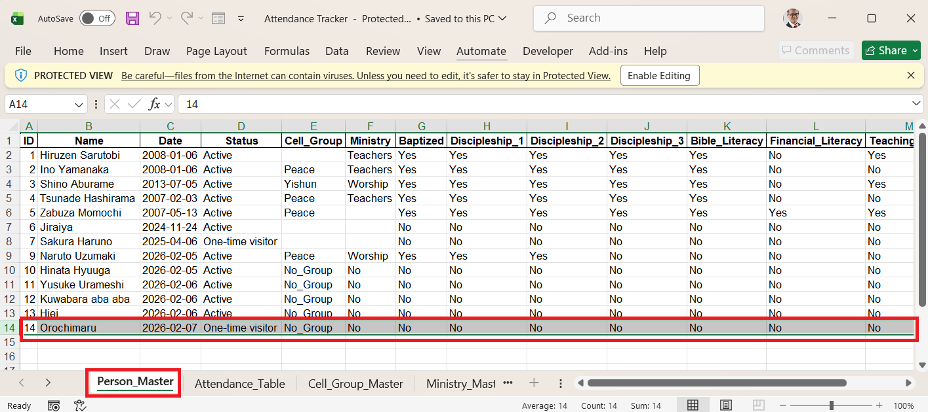

Attendance is recorded in ‘Attendance_Table’ worksheet
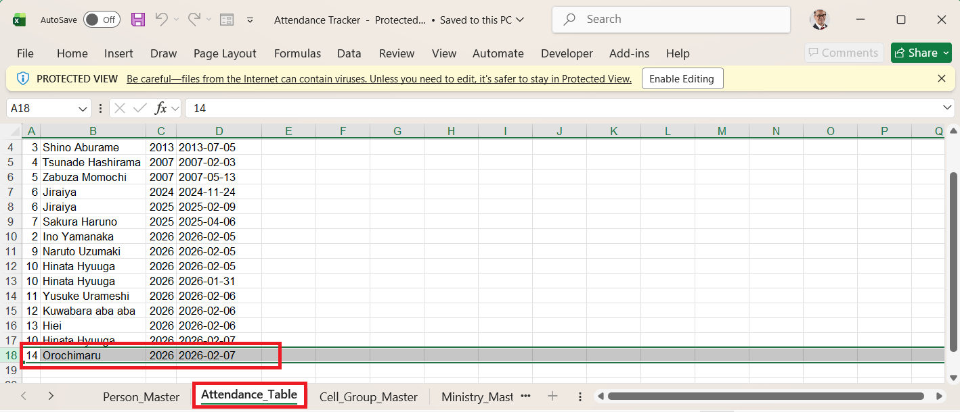

Maintaining Attendees details
By clicking button ‘Open Maintenance’ screen, new window ‘Person Maintenance’ screen will pop up.

Search the name of the person that needs to be maintained.
You may either:
- Press the Down Arrow key to highlight the correct name, or
- Click the dropdown arrow to manually select the name from the list
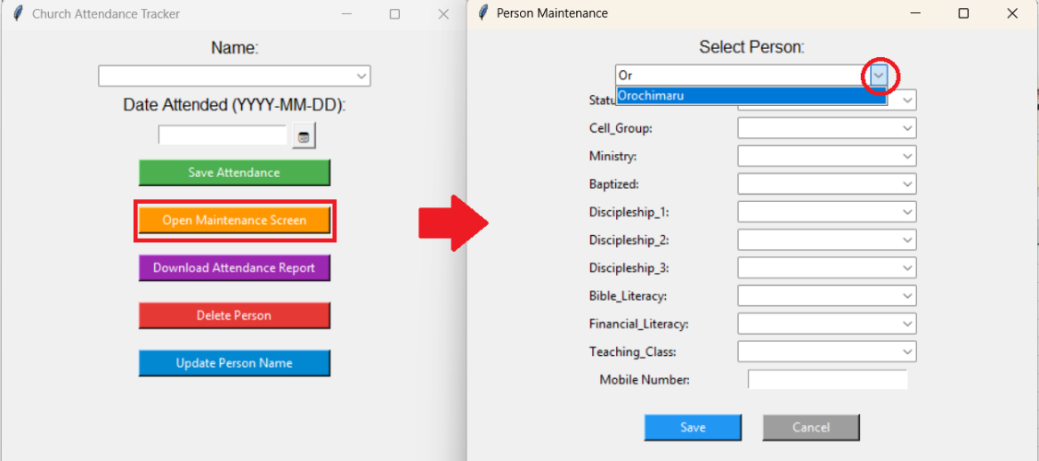
This will display all the details related to the customer
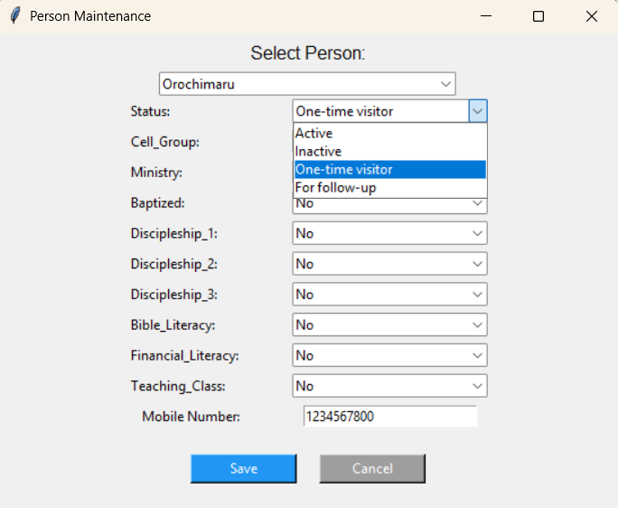

These are the fields maintained for each attendees
Fields | Type | Drop down values | Remarks
Status | Drop down list | Active
 |  | Inactive
 |  | One-time visitor | Default value when attendee is newly added
 |  | For follow-up | When attendee needs to be followed up
Cell Group | Drop down list | No_Group | Default value when attendee is newly added
 |  | *values from cell group master | Maintained in 'Cell_Group_Master' worksheet
Ministry | Drop down list | No | Default value when attendee is newly added
 |  | *values from ministry master | Maintained in 'Ministry_Master' worksheet
Baptized | Drop down list | No | Default value when attendee is newly added
 |  | Yes
Discipleship_1 | Drop down list | No | Default value when attendee is newly added
 |  | Yes
Discipleship_2 | Drop down list | No | Default value when attendee is newly added
 |  | Yes
Discipleship_3 | Drop down list | No | Default value when attendee is newly added
 |  | Yes
Bible Literacy | Drop down list | No | Default value when attendee is newly added
 |  | Yes
Financial Literacy | Drop down list | No | Default value when attendee is newly added
 |  | Yes
Teaching Class | Drop down list | No | Default value when attendee is newly added
 |  | Yes
Mobile Number | Text Input field | *for mobile number input

Once the fields are updated, clicking Save button will save the new information to ‘Person Master’ worksheet
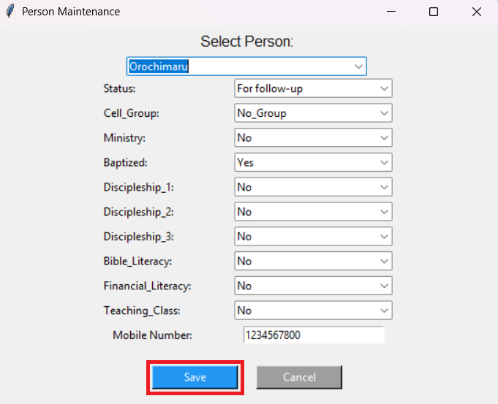
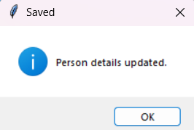

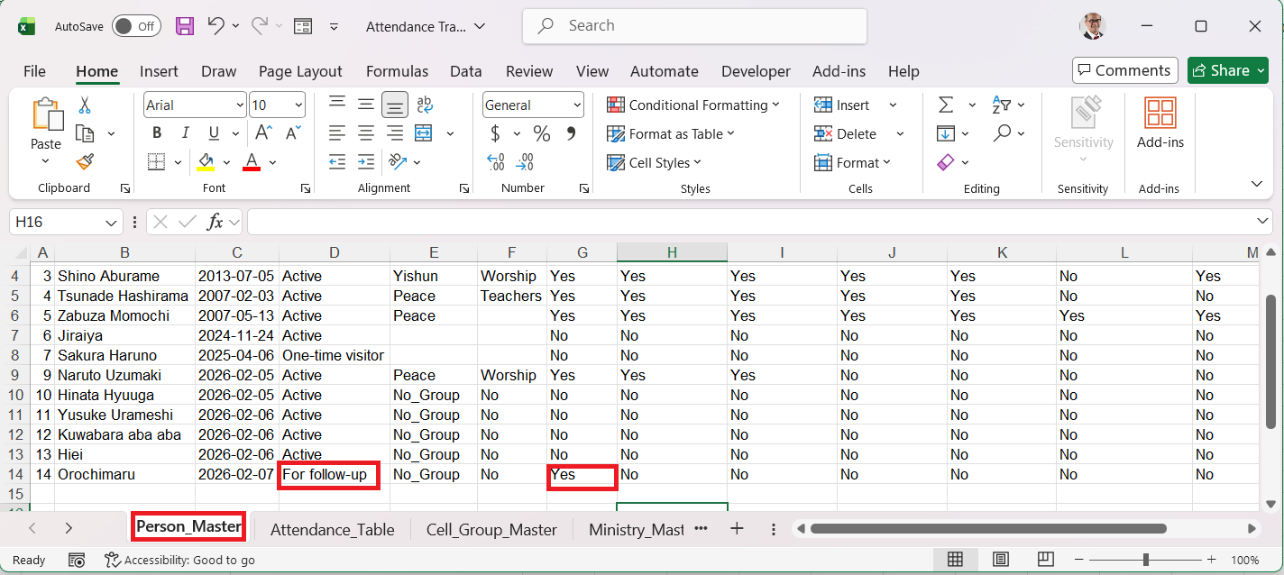

Download attendance report
Clicking the button ‘Download Attendance Report’ select the ‘From Date’ and ‘To Date’ and click ‘Generate Report’

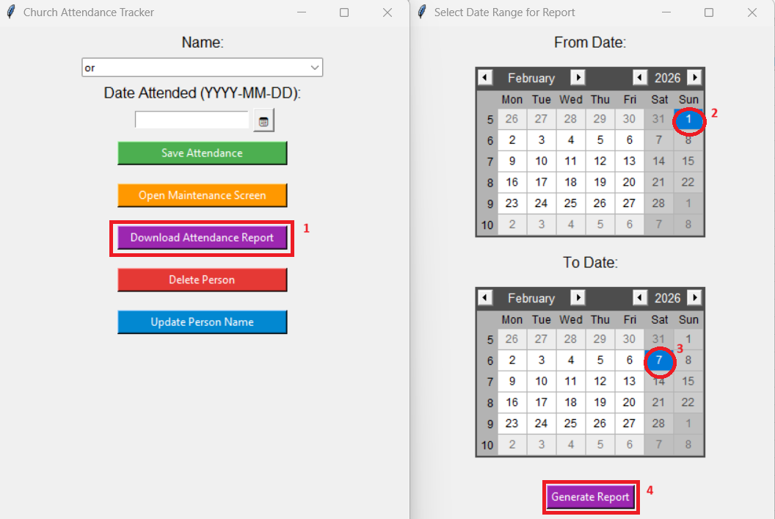

Excel sheet report will be downloaded and will be saved where the Attendance_Tracker and the program are saved.
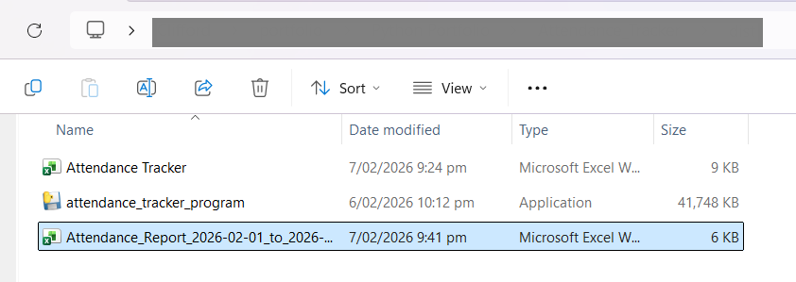
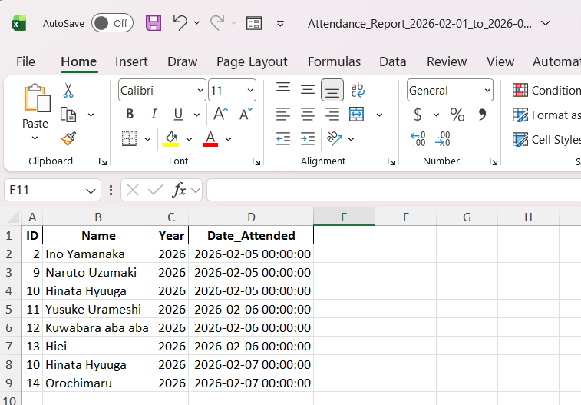

Delete Person to delete user and recorded attendance
Clicking ‘Delete Person’ button and selecting the attendee will delete the record in ‘Person Master’ worksheet as well as ‘Attendance_Table’ worksheet
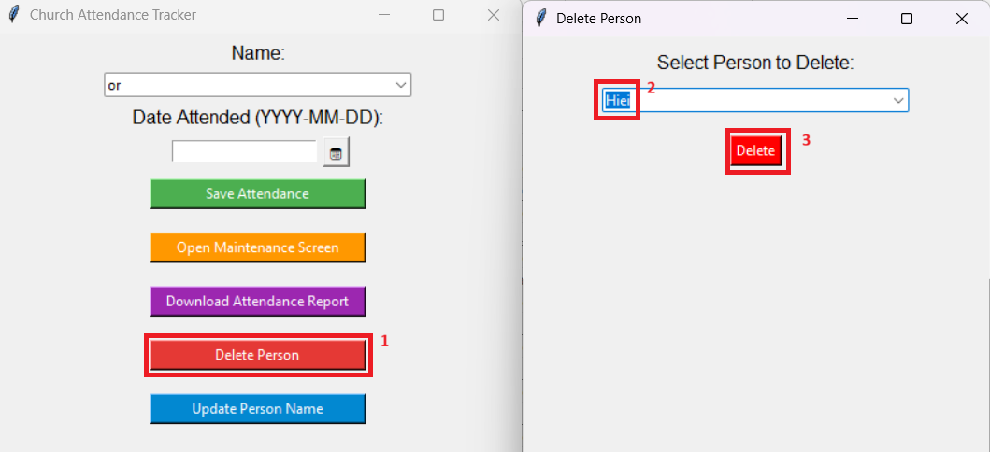

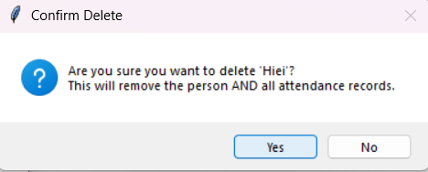

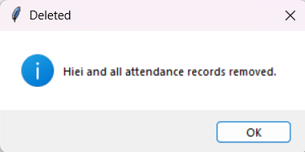

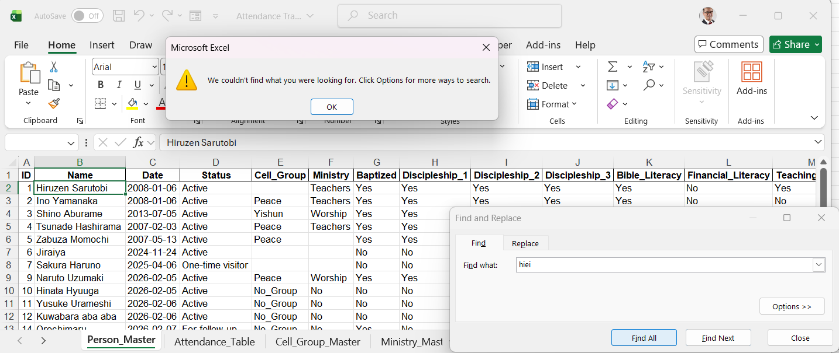

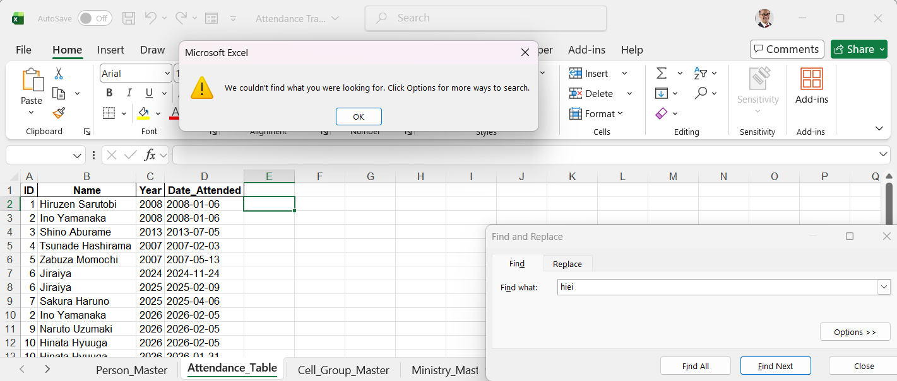

Update Person to update user and recorded attendance
Clicking ‘Update Person’ button and selecting the attendee will update the record in ‘Person Master’ worksheet as well as ‘Attendance_Table’ worksheet

